St. Xavier’s Catholic College of Engineering  Chunkankadai-629 003  SCIENCE AND HUMANTIES ASSOCIATION OF XAVIER’S (SHAX)  Annual Report (2024-2025) | 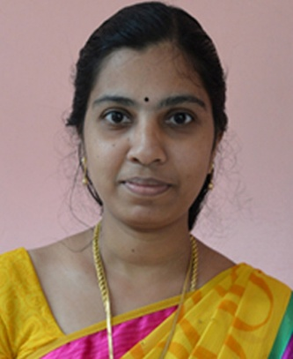
I am pleased to present the 26th Annual Report on the activities and achievements of SHAX, Science and Humanities Association of Xavier’s of the academic year 2023-2024. The Department of Humanities & Sciences encourages the students of all disciplines not only in their academic pursuit but also in furthering their career prospects and giving impetus to their creative potentiality. In addition to that the association inculcate ethical values and promote social responsibility through an innovative learning process in basic sciences and humanities. It also provides students with soft skills and behavioral training programs in order to develop their overall personality and social consciousness. Apart from science subjects the department also strengthens the liberal education of students by developing a deepened understanding of language, the value of critical reading and effective writing.
This academic year starts with a student induction program in order to help the new students adjust and feel comfortable in the new environment from 26th June to 7th July 2023. With continuation to that a two-week Student Induction Program (SIP) based on Universal Human Values (UHV) was conducted from 30th August to 12th November 2023.
The Inaugural ceremony of the 26th batch, BE/ B.Tech Programmes of St. Xavier’s Catholic College of Engineering was held on 9th November 2023. Rev. Fr. S.Jesu Retnam the Contact Person of the Diocese of Kuzhithurai and the President of the Governing council of St. Xavier’s Catholic College of Engineering presided over the ceremony. Dr. T.V. Venkateswaran, Senior Scientist, Vigyam Prasar, Dept. of Science& Technology, Govt. of India, highlighted the programme with his very presence.
In order to improve the students critical and creative thinking skills, a session on “Higher order thinking” was conducted for five days from 16/10/2023 to 20/10/2023 by the eminent personalities, Dr. S.Lourdunathan, Associate Prof &Head, Department of Philosophy, Arulanandhar College, Madurai and Rev. Dr. Selvaraj, Director, Indian Social Institute, Bangalore.
The Inauguration of SHAX’ was conducted on 30/11/2023 at 2.45 pm in the Conference hall. The Faculty Advisor introduced the new office bearers for this academic year. The annual plan was presented by the Secretary of SHAX. Dr. D. Arun Gladwin, Founder and Director of Vantage- a training institute in personality development and communication skill at Nagercoil, was the chief guest.
To build a strong relationship with the parents and to promote the well-being of the children a Parent Teachers Interaction meeting was conducted on 01/12/2023 at 2.30 pm in the Conference hall. In view of Tech fest-2024, SHAX – the first year association conducted few competitions like Paper Presentation and Poster Presentation to bring out the technical talents of the first year students on 14/03/2024.
A technical seminar on “Principles of Flight” was conducted on 27th April at the Einstein seminar hall for the first year students of EEE, Mech and Civil branches. Dr.J. Anish Jafrin Thilak, Assistant Professor, Dept. of Mech., Mepco Schlenk Engineering College, Sivakasi, was the Resource person.
For creating an opportunity to interact with the industry experts we have taken our first year Students to UST Global, Trivandrum on 23rd March and 29th April also to Vikram Sarabai Science and Space Centre, Trivandrum on 7th May.
Let me render my heartfelt gratitude to the Coordinator Dr.D.Judson for always being my greatest supporter throughout the year. I also thank all the faculty members and staff members of the Department of Humanities and Sciences , for their valuable cooperation and support.
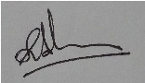
Faculty Advisor
(Ms.S.Asha Alice)

